The revenue mainly comes

from passenger tickets, while the costs include airplane expenses, fuel, crew, and

equipment.

1 Introduction

The airline industry and its operations have been a major focus of operation

researchers, especially since the advent of the jet age in the late 1950s, which was

followed by major technological advances. The industry has become a signiﬁcant

economic force from two perspectives: its own operations and its impact on related

industries such as tourism and aircraft manufacturing.

The revenue mainly comes

from passenger tickets, while the costs include airplane expenses, fuel, crew, and

equipment.

The revenue mainly comes

from passenger tickets, while the costs include airplane expenses, fuel, crew, and

equipment.

The revenue mainly comes

from passenger tickets, while the costs include airplane expenses, fuel, crew, and

equipment.

**Airlines Use Cases Crew Pairing**

**Project Description:**

A pairing is a round trip starting and ending at the home base, which is susceptible to constraints that arise due to laws and regulations. The purpose of the crew pairing problem is to generate a set of pairings with minimal cost, covering all flight legs that the company has to carry out during a predefined time period. The proposed solution is a two-phase procedure. For the first phase, the pairing generation, a depth first search approach is employed. The second phase deals with the se- lection of a subset of the generated pairings with near optimal cost.

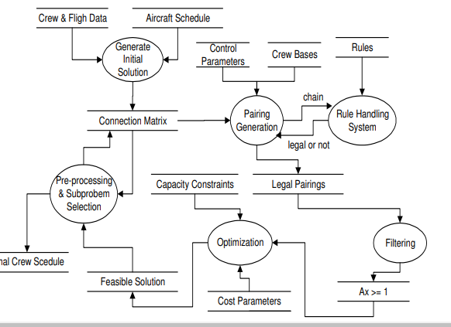

**Features and Problem approach:**

The airlines budget mainly includes airplane expenses, fuel, crew and airplane accessories and equipment. The airlines revenue created from passengers tickets.

Scheduled fights should have crew members, Crew scheduling is one of the major problem in airline industry.

Crew operating cost is the second largest cost component of an airlines' total operating marginal cost savings.

Basically we consider these features, Departure airport, Arrival Airport, Flight number, Departure Time and Arrival Time.

Deadhead: a pilot or a cabin crew, who is assigned to fly to a particular destination to assume a duty. In the flight where he or she is in, she's not supposed to work as a crew. They are paid.

Duty: Consecutive duties begin and end at same airport.

Layover: Rest period of overnight travel of crew member.

Elapsed flying time: "Actual time an airplane spends in the air, as opposed to time spent taxiing to and from the gate and during stopovers TAFB (Time away from base).

Crew members generally divided into two groups based on their role: the cockpit crew members are the pilot (captain), copilot and ﬂight engineer, all of whom are qualiﬁed to ﬂy one or more aircraft types. The cabin crew members are the cabin captain and the ﬂight attendants.

Post-pairing rest a rest period between two consecutive pairings that respects minimum and a maximum duration.

Post-pairing a rest period between two consecutive pairings that contains complete day off (from midnight to midnight)

.Aircraft route a sequence of air legs ﬂown by a speciﬁc aircraft.

Airlines divide the overall decision problem into two closely related procedures: planning and recovery.

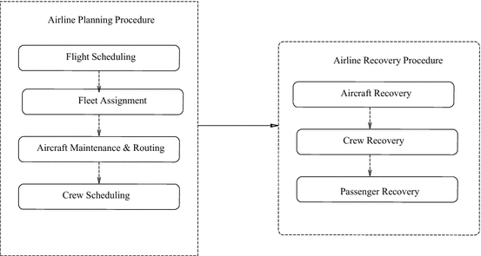

Scheduling applications like crew scheduling and crew rostering lead to very large and difficult optimization problems with long computation times. Solving such problems inacceptable time with exact algorithms is impossible due to the combinatorial explosion that characterizes most of these problems.

**Heuristics** are often used in order to reduce the search space and improve the computational tractability of these problems.

**Heuristic function:**

The subgroups as well as a predictive model in a single learning task and the subgroups correspond to interesting patterns found with respect to multiple classes. The subgroups are prioritized, with respect to their multi-class heuristic scores, and used to form a binary tree such that the most discriminative and significant subgroups are added first.

The choice of the heuristic function is an important issue often overlooked when dealing with multi-class domains. This is because most rule learning systems employ binary heuristic measures in one-vs-rest, one-vs-one or all-vs-all paradigms and run into problems of combining them or their predictions in a sub-optimal way.

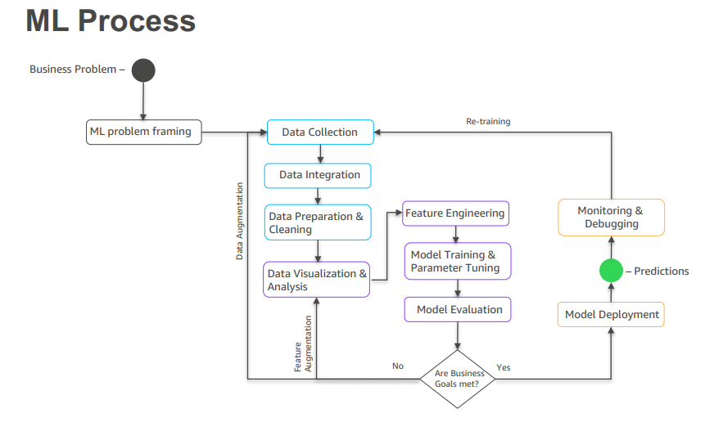

**Pairing Generation Algorithm:**

Pairing Generation Algorithm Description The pairing generator creates legal pairings by connecting legs to each other. The pairing generator is aided by a pre-processed connection matrix that shows the acceptable connections between pairs of legs. In addition, there exists a legality module that calculates the properties of each chain and validates all the applicable rules.

The parallelization of the generator and the optimizer have given rise to new business advantages of the Carmen System product. Analysis of the various parallelization approaches for both the generator and the optimizer.

**Variable-Backtrack Modification in DFS:**

**Depth-First Search:** The first algorithm I will be discussing is Depth-First search which as the name hints at, explores possible vertices (from a supplied root) down each branch before backtracking. This property allows the algorithm to be implemented succinctly in both iterative and recursive forms.

The new legal pairing generated using enhanced-DFS covers more unique nodes than the new legal pairing generated using original-DFS.

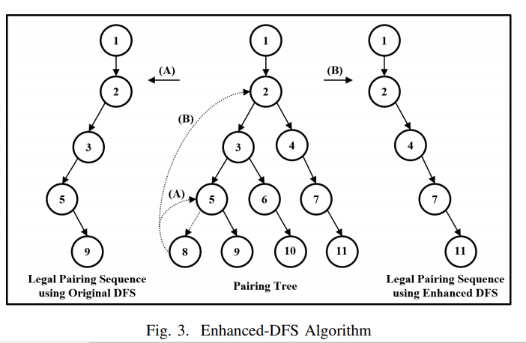

**Cost constrained Pairing Generation:**

LEGAL PAIRING GENERATION USING SEQUENTIAL ALGORITHM (SA) AND PARALLEL ALGORITHM (PA)

**Conclusion:**

The crew planning problem has been successfully solved on a loosely connected network of workstations (NOW) using advanced computational techniques and efficient communication patterns. The parallelization of the successful sequential system of Carmen Systems AB guarantees that the results are immediately useful and applicable to a large number of airlines scheduling problems. The parallel pairing generator component of the crew scheduling process achieves a linear speedup on the number of processors and can be efficiently scaled to a large number of processors. The novel parallel optimizer approach of the paper also achieves almost linear speedups for large problems solved on a small number of workstations.

Crew members Generally divided into two groups based on their role: the

cockpit crew members are the pilot (captain), copilot (ﬁrst ofﬁcer), and ﬂight

engineer, all of whom are qualiﬁed to ﬂy one or more aircraft types. The cabin

crew members are the cabin captain and the ﬂight attendants.

–Post-pairing rest A rest period between two consecutive pairings that respects a

minimum and a maximum duration.

–Post-pairing A rest period between two consecutive pairings that contains a

complete day off (from midnight to midnight).

–Aircraft route A sequence of air legs ﬂown by a speciﬁc aircraft.

Crew members Generally divided into two groups based on their role: the

cockpit crew members are the pilot (captain), copilot (ﬁrst ofﬁcer), and ﬂight

engineer, all of whom are qualiﬁed to ﬂy one or more aircraft types. The cabin

crew members are the cabin captain and the ﬂight attendants.

–Post-pairing rest A rest period between two consecutive pairings that respects a

minimum and a maximum duration.

–Post-pairing A rest period between two consecutive pairings that contains a

complete day off (from midnight to midnight).

–Aircraft route A sequence of air legs ﬂown by a speciﬁc aircraft.